Spring onion and Cheddar stuffed bread
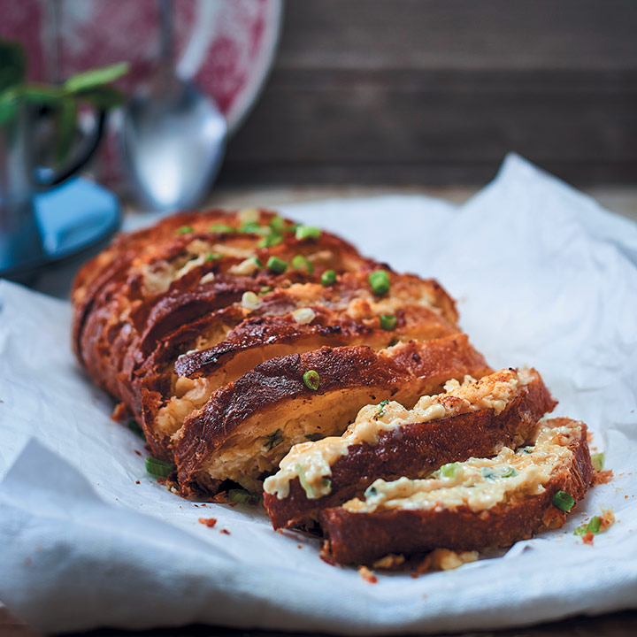
This is perfect for feeding a crowd at your next braai, where you can serve it as a side dish, instead of garlic bread

Spring onion and Cheddar stuffed bread
Serves: 6
Cooking Time: 30 mins

INGREDIENTS
- 300g matured Cheddar, grated
- 120g cream cheese, at room temperature
- 200g good quality mayonnaise
- 30ml (2 tbsp) milk
- 3 spring onions, finely sliced + extra slices, to garnish
- 50g butter, softened
- 1 loaf ciabatta

INSTRUCTIONS
1
Preheat the oven to 200˚C. In a bowl, combine the matured Cheddar, cream cheese, mayonnaise, milk, spring onions and butter, and stir to combine well.
2
Cut the ciabatta into 1,5cm-thick slices, but do not slice through the base of the bread. Spread a thick layer of the cheese mixture between each slice, then place the loaf in a baking tray. Bake in the preheated oven, 20 – 30 minutes, until the cheese has melted, and the bread is lightly golden and crisped in places.
3
Serve the bread warm with extra spring onion slices sprinkled over.

