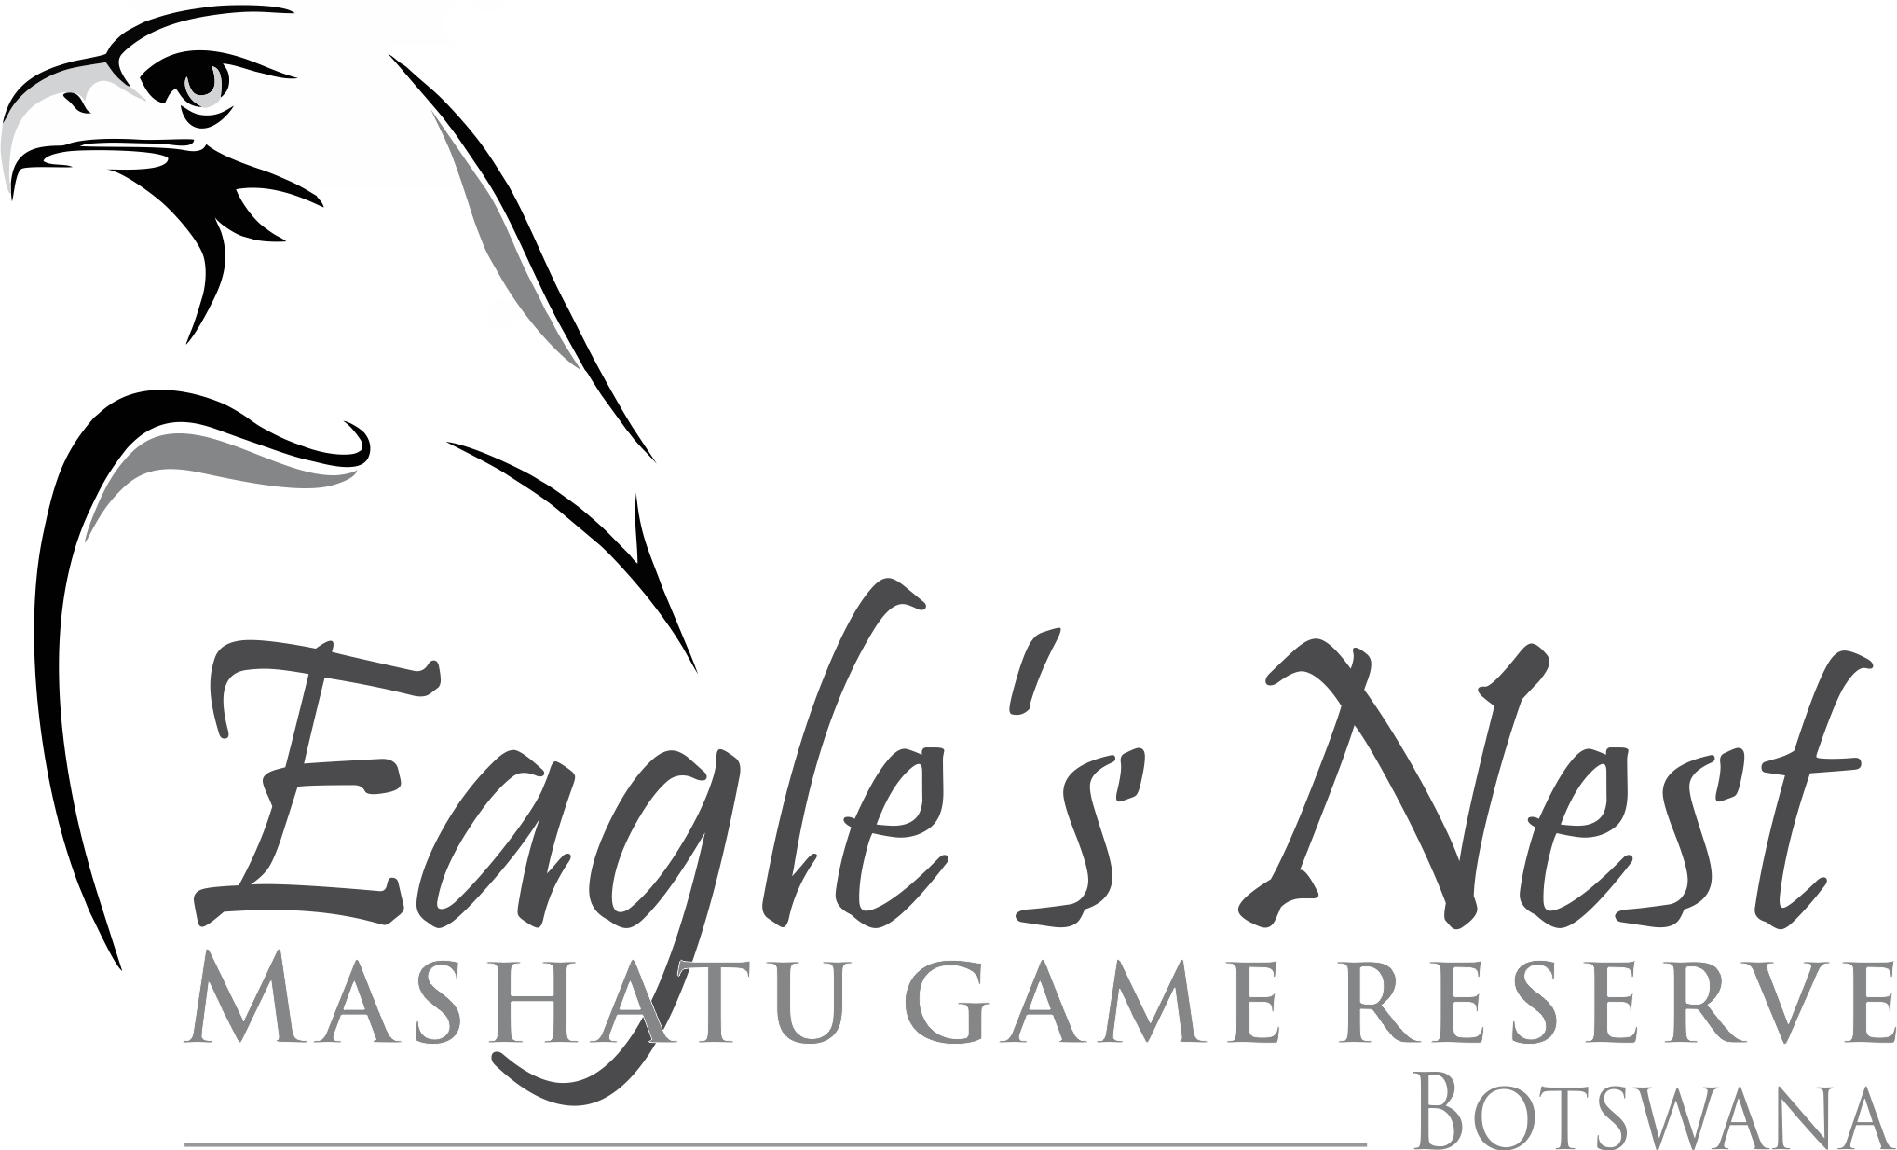

INDEMNITY AND WAIVER
I/we, the undersigned,

agree, understand and accept that my/our travelling to/from, visit, stay and participation in activities and excursions of any nature in and around the premises known as Eagle’s Nest comprising of a stand on Portion 1 of Merryhill 4-MS together with the dwelling units, living area, outbuildings, staff complex and other facilities (the “Camp”) leased by Eagle’s Nest Lodge (PTY) LTD, a private company duly incorporated in terms of the laws of the Republic of Botswana, with registration number UIN BW 00001886700 and registered address to Plot 113, Unit 28, Kgale Mews, Gaborone, Botswana and shall include its agents, representatives of any form, associates, affiliates, subsidiaries, holding companies, shareholders, directors, and employees (the “Company”) and/or on the Mashatu Nature Reserve (including such areas over which the Company have traversing rights) (the “Reserve”) is/are undertaken at my/our own risk;

recognise that the Camp and Reserve are located within a wilderness area which is populated with wild animals, with attendant high level of risk, and acknowledge that the Camp and the Reserve are visited by other members of the public and recognise that I/we am/are at a higher level of risk of contracting infectious or contagious diseases (including, but not limited to, Covid-19), which risks I/we accept, on my/our own behalf and on behalf of my/our spouses, partner(s), child or children (minor or adult), relatives and for any person accompanying me/us to the Reserve and/or Camp;

agree, understand and accept that the Company and its servants, guests, invitees, insurers and/or any other persons connected whether directly or indirectly with the Company, the Reserve and/or the Camp or the running thereof are not responsible in any way for any bodily harm, injury, the contracting of any infectious or contagious diseases (including, but not limited to, Covid-19), death and/or damage to or loss of property suffered by me/us, my/our spouse(s), my/our partner(s), my/our child(ren) whether minor or adult, my/our relative(s) and/or any person(s) accompanying me/us to the Reserve and/or Camp;

irrevocably and unconditionally waive and abandon any claim(s) which I/we, my/our dependents, or my/our executors, may have at any time against the Company, its servants, guests, invitees, insurers and/or any other persons connected whether directly or indirectly with the Reserve and/or the Camp or the running thereof arising out of, or in connection with, or as a result of:

any loss or damage to property owned by me/us, my/our spouse(s), my/our partner(s), my/our child(ren) whether minor or adult, my/our relative(s) and/or any person(s) accompanying me/us to the Reserve and/or the Camp; and/or

the bodily harm, the contracting of any infectious or contagious diseases (including, but not limited to, Covid-19), injury or death suffered by me/us, my/our spouse(s), my/our partner(s), my child(ren) whether minor or adult, my relative(s) and/or any person(s) accompanying me/us to the Reserve and/or the Camp, during the course of or as a consequence of my/our visit, stay and/or participation in activities and excursions of any nature whatsoever,

and hereby irrevocably and unconditionally indemnify, hold harmless and absolve the Company, its servants, guests, invitees, insurers and/or any other persons connected whether directly or indirectly with the Company, the Reserve and/or the Camp or the running thereof against and from any or all claims, all actions, applications, suits, proceedings, hearings, investigations, charges, complaints, demands, interdicts, judgements, orders, decrees, directives, rulings, damages, dues, penalties, fines, costs, reasonable amounts paid in settlement, liabilities, obligations, tax, liens, losses, compensation, expenses and fees, including reasonable fees and expenses of attorneys, counsel, accountants, consultants and experts, howsoever and whatsoever which may arise in connection with, or as a result thereof;

hereby bind my/our dependents, heirs, trustees, executors, administrators, third parties and/or assigns to the terms and conditions of this document together with any rules, regulations and/or protocols (including, but not limited to Covid-19 protocols) issued from time to time by the Company (copies of which are in the possession of each member of the Company) and further warrant that I/we am/are duly authorised to bind my/our minor child(ren) accompanying me to the Camp and/or the Reserve to the terms and conditions set out herein;

each of the indemnities, disclaimers, waivers, releases and other provisions contained herein are separate and severable provisions which are individually and jointly enforceable. In the event that any one or more of the provisions herein are found to be invalid, unlawful and/or unenforceable such provisions will be severable from the remaining provisions and the remaining provisions shall continue to be valid, in full force and effect; and

accept that the entire relationship between the Company and myself/ourselves, including this document, and any disputes, be they in contract or delict, shall be governed by the laws of the Republic of South Africa.

Signed at on 20

 | Full Name and Surname | Identity/Passport Number | Signature
1
2
3
4
5
6
7
8
9
10

Each party signing in his/her personal capacity and as the legal guardian of his/her minor child/children (if applicable)

