Cheese & Herb Pull-Apart Bread
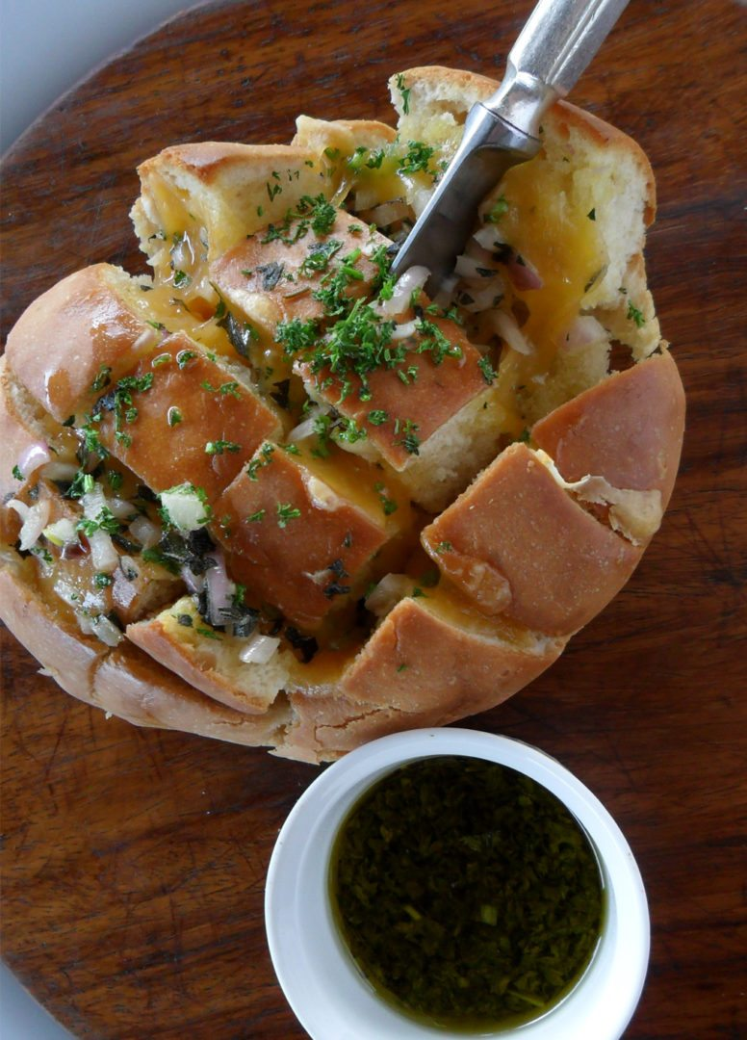

Ingredients
- 10 x mini rounds of plain bread
- 1 cup chopped red onion
- ¼ cup chopped parsley
- ¼ cup chopped thyme or oregano
- 2 cups sliced cheddar cheese
- ¼ cup poppy seeds
- 1 cup melted margarine
- Salt, to sprinkle on top

Directions
- Preheat the oven to 180°C
- Bake the mini breads and once cooked, allow to cool
- Fry the onion in a little bit of oil until soft
- Melt the margarine and add the onion, parsley, thyme and poppy seeds; mix well
- Cut the bread across (not all the way to the bottom) as per the picture
- Place cheese slices into the bread and pour the melted mixture into the slices
- Sprinkle with salt
- Just before serving, place the breads into the oven to melt the cheese
- Serve with parsley dip

