Braai marinade
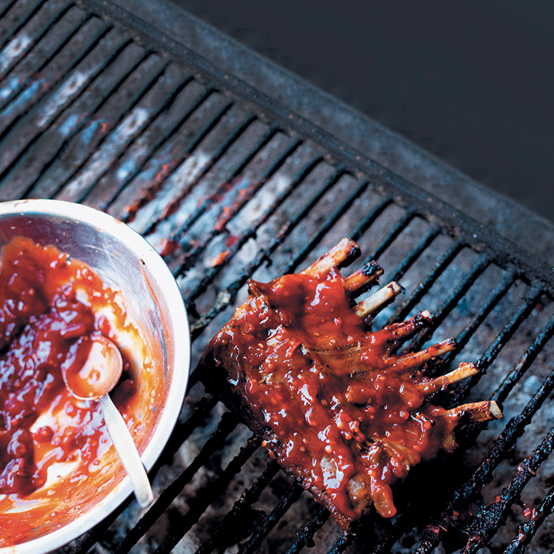

Ingredients
- 45ml (3 tbsp) chutney
- 45ml (3 tbsp) tomato sauce
- 45ml (3 tbsp) mustard
- 45ml (3 tbsp) chilli sauce (optional and according to preference)
- 45ml (3 tbsp) white wine vinegar
- salt and pepper, to taste
- 1 chicken/beef/mutton stock cube, crumbled
- 1 large onion, cut into strips
- 1 each of green, red and yellow peppers, seeded and finely diced
- 2 or 3 red or green chillies (optional and according to taste)
- 2kg meat cutlets of choice or chicken portions

Instructions
1
Mix the chutney, tomato sauce, mustard, chilli sauce and vinegar into a thick paste. Season and add the stock, onion and peppers. Mix well.
2
Rub the mixture over the meat and refrigerate overnight to marinate.
3
Prepare the coals for the braai.
4
When the coals are ready, remove the meat from the marinade and braai, turning occasionally, until cooked according to your preference.

