Amarula Coffee

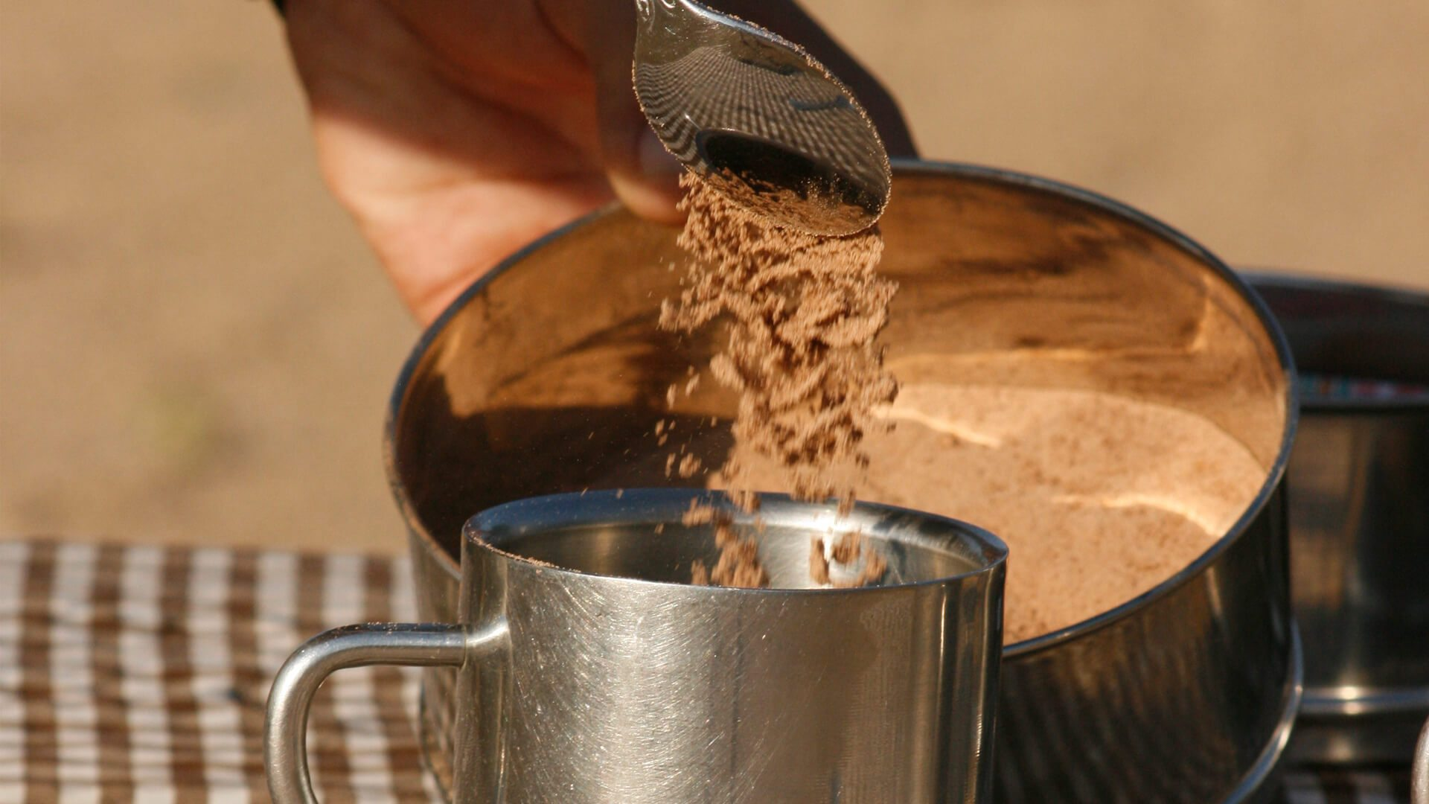

Ingredients
- Hot chocolate powder
- Milk
- Filter coffee prepared in a French press
- Amarula (or alternative cream liqueur)

Directions
- Add 3 heaping spoons of hot chocolate powder to each mug
- Add a splash of milk so that you can stir the powder into a chocolatey paste
- Pour hot filter coffee over the paste and stir
- Continue stirring and add a (generous) splash of Amarula
Voilà … now let the safari memories come flooding back!

